**APPLICATION GATEWAY**

1. Create an application gateway from Azure Portal. That will automatically create IPv4, Vnet. 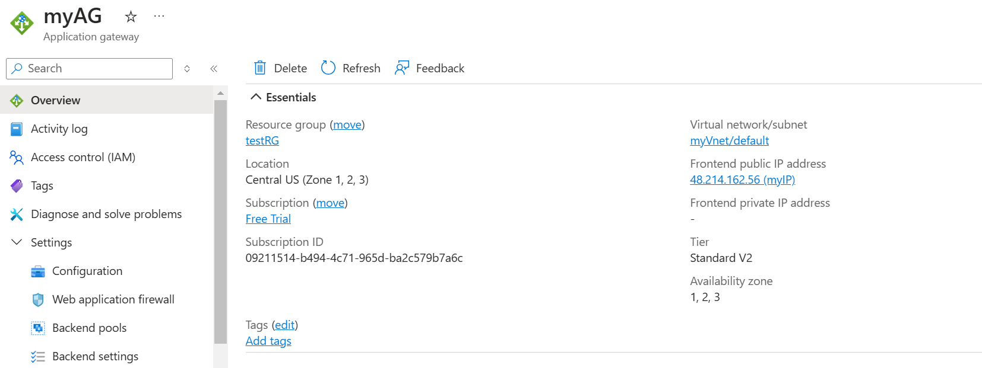
2. Now, there are 5 important things. Please find the screenshot of each of the term in order.
   1. Frontend IP 🡪 The frontend IP is of App Gateway
   2. Listeners 🡪 Listeners are the port on which AG listens
   3. Rules 🡪 Rules are routes which route the traffic from Frontend ID to Backend
   4. Backend Pool 🡪 The backend pool is where you mention the URL of the web apps
   5. Backend Settings 🡪 This is where you define few settings regarding backend applications

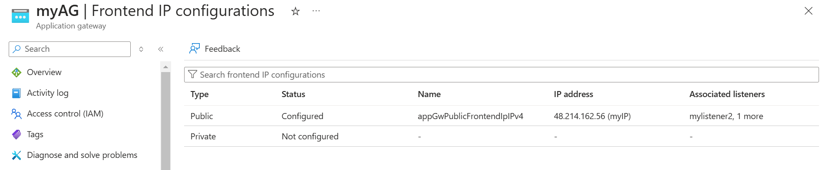

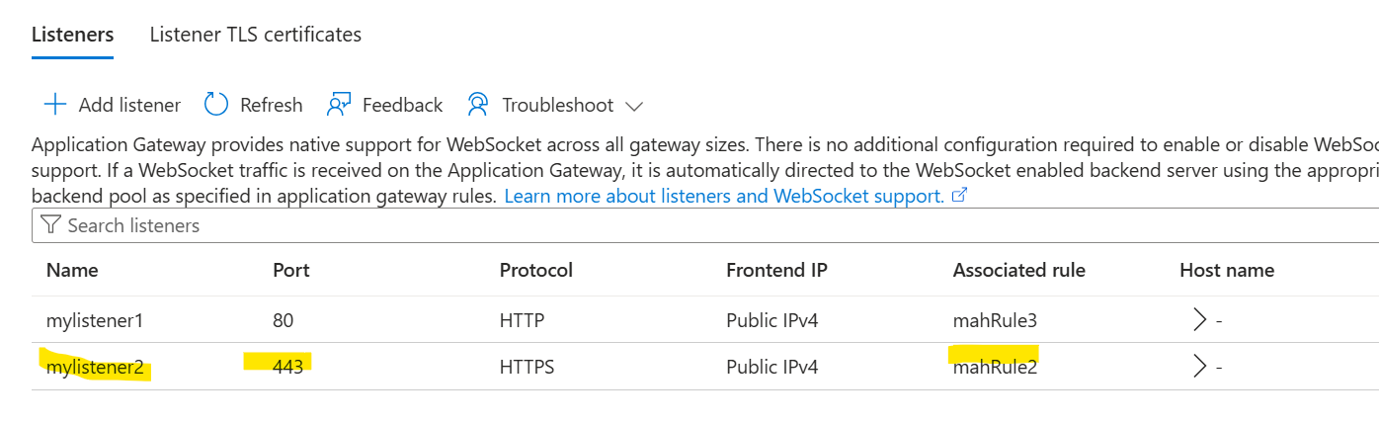

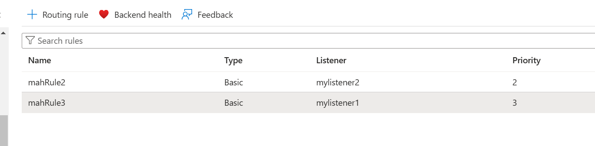

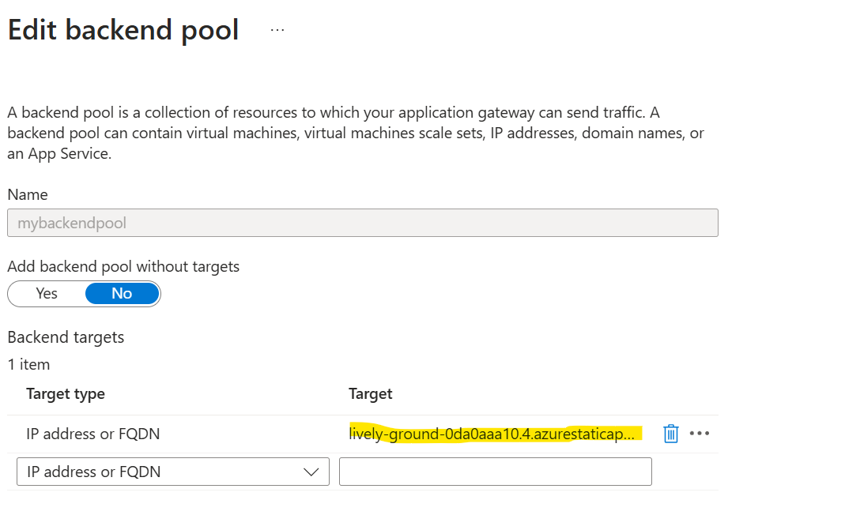

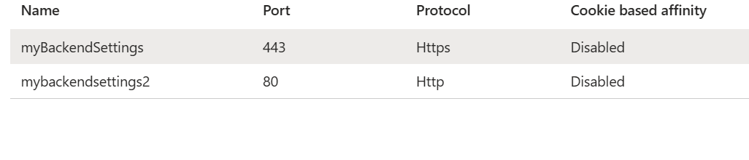

1. Now, below are important settings that are important. There is no major setting for IP and listeners. Listeners require backend pool and backend settings to be created beforehand to be associated. The backend settings below are important. Override hostname ‘YES’ and tick the option hostname from backend target. If you don’t do this, then the health probe will fail and the traffic would not go to the backend. See, when you choose 443, the portal asks you to upload a cert, I uploaded self-signed certificate, but the certificate of Static Web App which is on backend will not match and the health probe will fail. So, when you override the hostname, it ignores the mismatch and the site loads successfully.

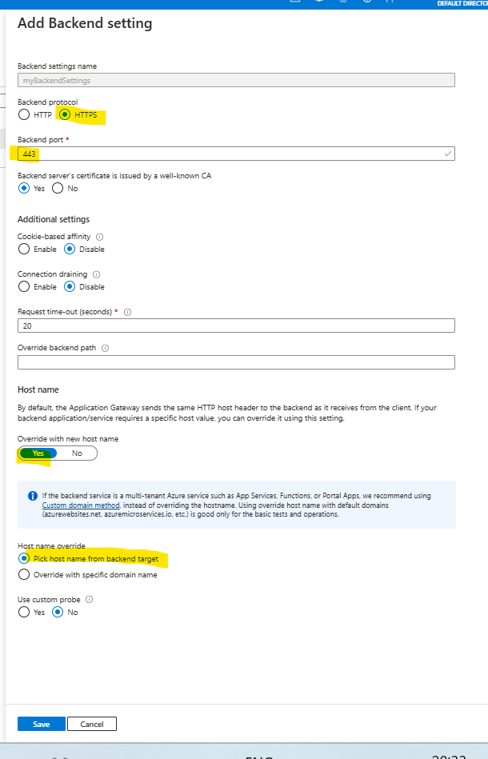

1. Successful app routing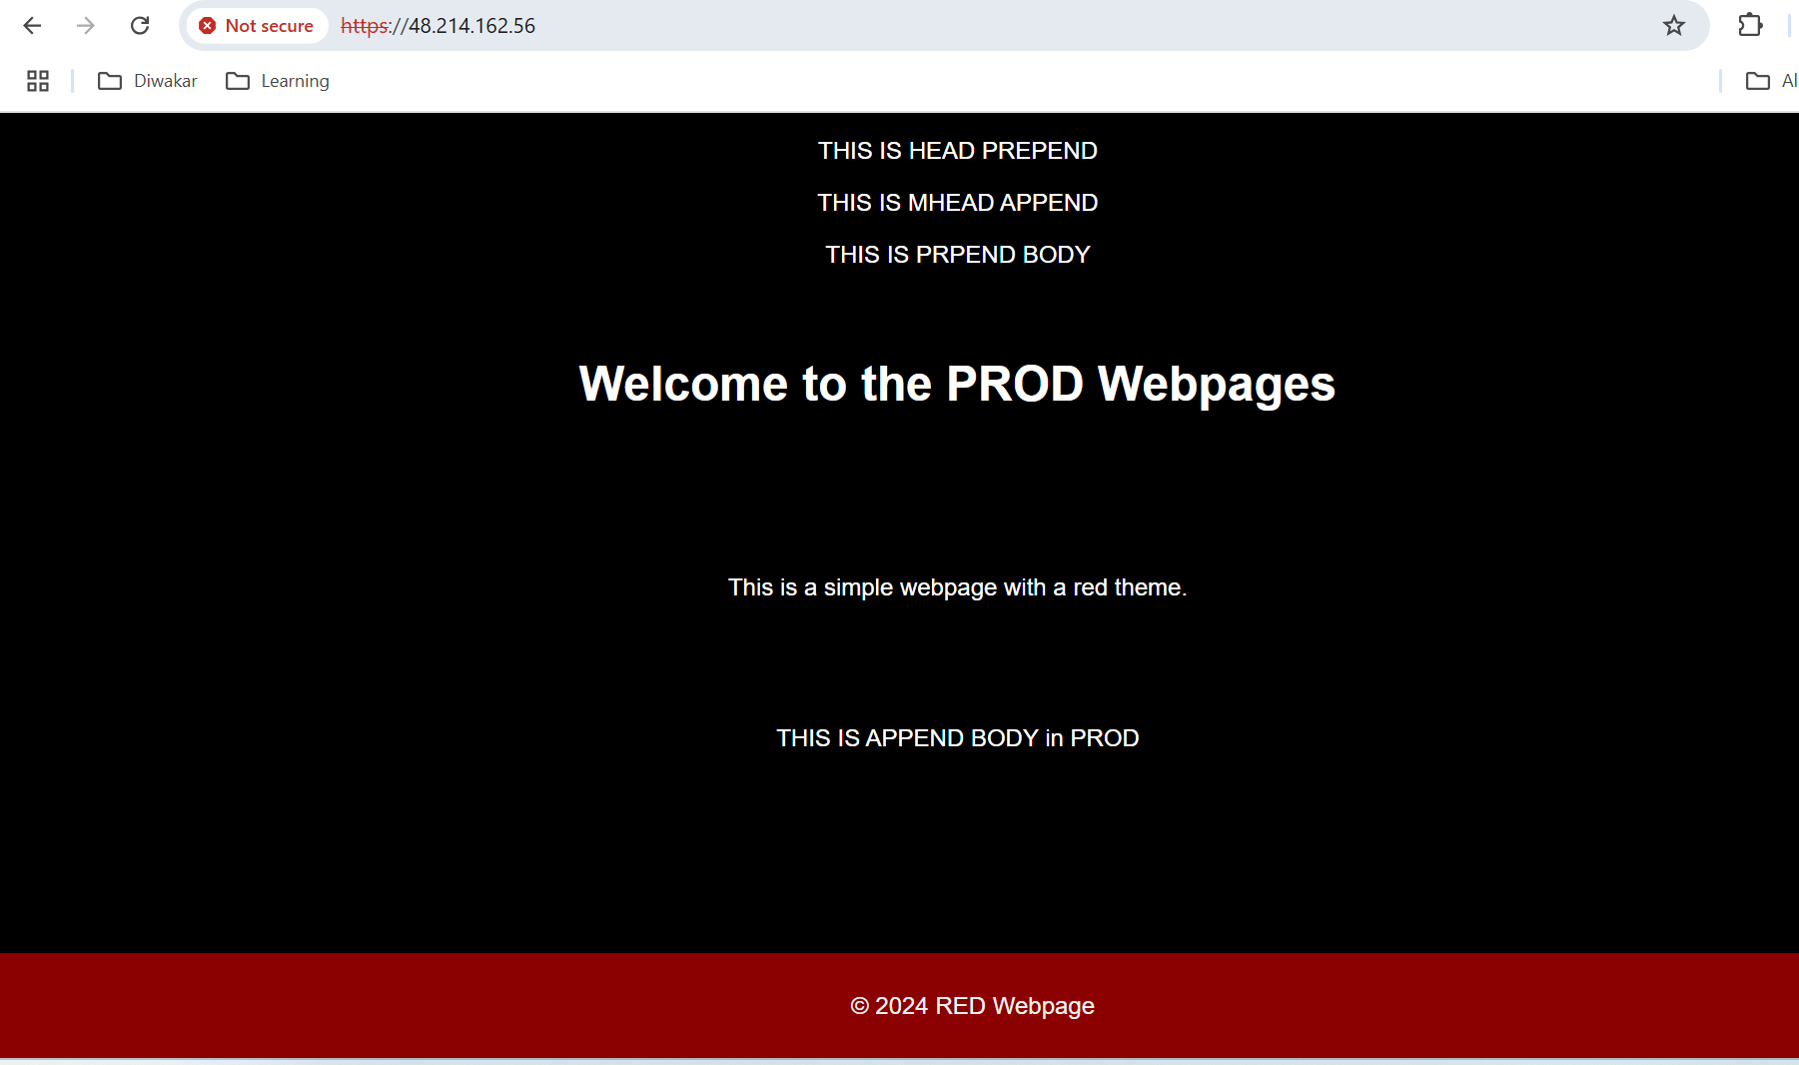
2. You can even add the images path through Static Web App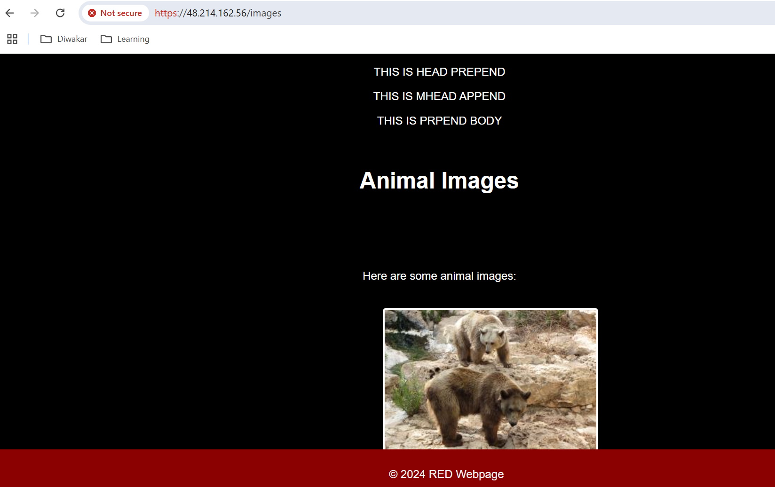
3. Remember, there is no need to make any configuration changes from Web-App end. As the traffic is routed from App Gateway to Static Web App. 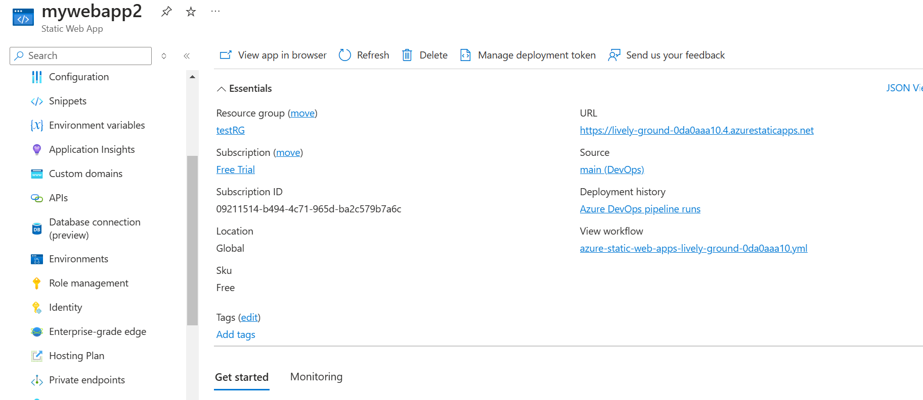
4. Also, remember there cannot be same apps listening on same port, i.e. there cannot be two listeners with same port. See below screenshot. 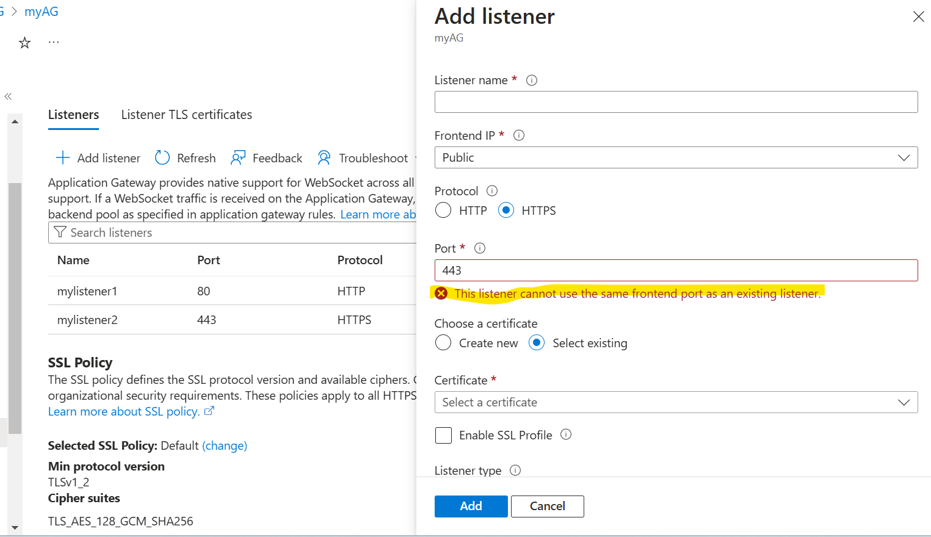
5. I have added 80th port for another webapp in backend pool, so it redirects to that app when we hit the IP with http (http://48.214.162.56/). (Ignore that the app is failing, because no deployment file was uploaded in that) 